Validation of Prognostic Scores for Fournier's Gangrene

Franco Troilo1, Federico Carballo2, MAAC, MSACP, Pablo Farina3, MAAC, MSACP, Leonardo L. Dimasi4, MAAC

Surgery Division, Pirovano Hospital. Buenos Aires, Argentina

1Surgeon. Surgery Resident Instructor

2Surgeon. Coloproctology Specialist. Staff Member, Surgery Division, Coloproctology Sector

3Surgeon, Coloproctology Specialist. Head of On-Call Services

4Surgeon. Head of the Surgery Unit

**ABSTRACT**

**Introduction:** The prognosis of Fournier's gangrene is directly related to adequate staging of the severity and extent of the condition.

**Objective:** To validate the FGSI, UFGSI, and sFGSI prognostic severity scores for Fournier's gangrene. To compare the usefulness of each in a specific population.

**Design:** Retrospective observational cohort study.

**Methods:** Forty-four cases of patients diagnosed with Fournier's gangrene treated between January 2014 and April 2024 were retrospectively reviewed. The FGSI, UFGSI, and sFGSI scores were calculated in this population and compared with those published by the respective authors. The variables analyzed were age, sex, presence of diabetes, obesity, smoking, oncological diseases, cardiovascular diseases, and triggering factor. Hospital stay, requirement for intensive care, requirement for ostomy, isolated germ, and associated mortality were also analyzed.

**Results:** The mortality rate was found to be 25%. A statistically significant difference was observed in the mortality of patients over 60 years of age (p=0.035) and in patients with a history of cancer (p=0.028). The sensitivity and specificity for FGSI were 90% (95% CI: 71.4–100%) and 93.3% (95% CI: 84.5–100%), respectively. For UFGSI, the sensitivity and specificity were 100% (95% CI: 69.1–100%) and 76% (95% CI: 57.7–89.9%), respectively. For sFGSI, the sensitivity and specificity were 80% (95% CI: 55.2–100%) and 73.3% (95% CI: 57.3–87.3%), respectively.

**Conclusion:** The three scores under scrutiny were validated with statistically significant results. Patients diagnosed with Fournier's gangrene and scores greater than 9 on the FGSI and UFGSI and greater than 2 on the sFGSI were associated with high mortality rates. The UFGSI demonstrated a higher level of sensitivity in our population. The present study identified two independent risk factors for higher mortality from Fournier's gangrene: oncological pathology and age over 60 years.

***Keywords:*** *FGSI; sFGSI; UFGSI; Prognostic score*

**INTRODUCTION**

Fournier's gangrene is a type of necrotizing fasciitis that occurs in the perineal region and genital organs. In 95% of cases, the cause can be identified, and it may originate from a colorectal, genitourinary, or skin infection, among others.1

The prognosis of the disease is closely linked with the timing of diagnosis and the therapeutic approach employed. Delayed treatment is associated with high mortality, with rates reaching up to 90%.2

Since the 1990s, various diagnostic and prognostic scores related to Fournier's gangrene have been developed. These were the FGSI (Fournier Gangrene Score Index) in 2004,³ the LRINEC Score (Laboratory Risk Indicator for Necrotizing Fasciitis) in 2010,⁴ the UFGSI (Udulag Fournier's Gangrene Severity Index) in 2010,⁵ and a simplification of the FGSI in 2014. Given the variety of prognostic scores associated with their varying complexity, this study proposes to validate the different scores and thus unify the use of the most sensitive and specific one for our population.

**MATERIALS AND METHODS**

A retrospective cohort study was conducted from January to April 2024. Patients who presented at the emergency department of our hospital with a diagnosis of Fournier's gangrene were included in the study. Those with incomplete care records or who lacked the

necessary data to complete the scores were excluded. To carry out the analysis, a database was created in which the FGSI, sFGSI, and UFGSI scores were calculated.

The FGSI was calculated using the following variables: temperature, heart rate, respiratory rate, serum sodium, serum potassium, serum creatinine, hematocrit, white blood cell count, and serum bicarbonate. To calculate the UFGSI, age and compromised body surface area were added to the FGSI. The latter was stratified into three groups as established by the UFGSI (Fig. 1). A value of 9 was taken as the cutoff point. The sFGSI includes only creatinine, hematocrit, and potassium. The value 2 was used as the cutoff point. Table 1 shows the scores assigned to each variable.

The objective of this research is to validate the FGSI, UFGSI, and sFGSI prognostic scores for Fournier's gangrene and to analyze the usefulness of each in a specific population.

**Statistical analysis**

The statistical analysis was conducted using StatistixⓇ version 9.0 and SPSSⓇ version 19.0. Univariate analysis for categorical variables was performed using Fisher's test, and for continuous variables using Student's t-test. For all comparisons, a p<0.05 was considered statistically significant. Kaplan-Meier curves were used for survival analysis.

The authors declare no conflicts of interest. **Franco Troilo:** [**Francotroilo.94@hotmail.com**](mailto:Francotroilo.94@hotmail.com)

Received: June 10, 2025. Accepted: August 20, 2025.

Franco Troilo: <https://orcid.org/0000-0002-3740-3765>, Pablo Farina: <https://orcid.org/0000-0002-1869-1861>, Federico Carballo: <https://orcid.org/0000-0002-8513-4715>,

Leonardo L. Dimasi: <https://orcid.org/0009-0004-9147-577X>

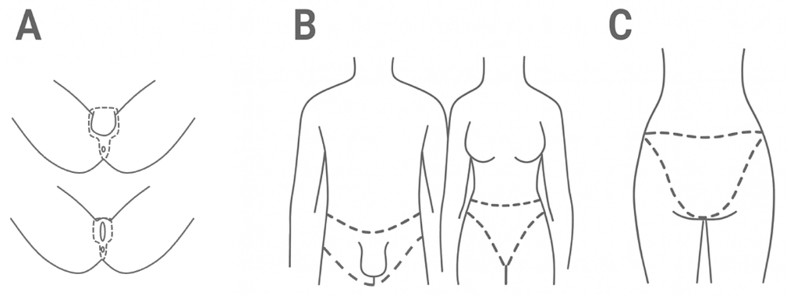

***Figure 1.*** *Anatomical boundaries used to classify the grade of spread.* ***A.*** *Anatomical surface of grade I spread.* ***B.*** *Anatomical surface of grade II spread, showing a frontal view of a man and a woman.* ***C.*** *Posterior view. Spread of the disease to other parts is considered grade III. The dotted lines in figures B and C show the margins of the pelvic region.*

**RESULTS**

Of the total 44 patients diagnosed with Fournier's gangrene, 4 were excluded due to incomplete records. The analysis included a total of 40 patients, of whom 30 were male (75%). Forty percent of the women and 53.3% of the men were over 60 years of age. The mean age of the sample was 58 years (95% CI: 52.6–63.3), with a median age of 59 years (range: 16–78 years). The mean length of stay was 16.8 days (95% CI: 13.08–20.51), ranging from a minimum of three days to a maximum of 65 days.

The most prevalent comorbidities and risk factors included diabetes (55%, n = 22), age ≥ 60 years (50%, n = 20), cardiovascular disease (47.5%, n = 19), obesity (45%, n = 18), smoking (45%, n = 18), and cancer (22.5%, n = 9). Only one patient had HIV, and only one had HCV.

Among the triggering factors, 60% were perianal lesions (n=24); 15% were oncological conditions (n=6: 5 rectal cancers and 1 endometrial cancer); and 12.5% ​​were perineal trauma (n=5). Furthermore, 2 cases were associated with sacral pressure ulcer (5%), and 2 others occurred after gynecological or obstetric postoperative complications (5%), including one complication of total abdominal hysterectomy with bilateral salpingo-oophorectomy and one of episiotomy. Finally, one case was associated with osteomyelitis, with a prevalence of 2.5%.

The extent of gangrene was classified by grades using the UFGSI classification system. Of the patients, 47.5% had grade I gangrene (n = 19; 5 women and 14 men), 30% had grade II gangrene (n = 12; 1 woman and 11 men), and 22.5% had grade III gangrene (n = 9; 4 women and 5 men). Specifically, 50% of women and 46.7% of men had grade I gangrene, 10% of women and 36.7% of men had grade II gangrene, and 40% of women and 16.7% of men had grade III gangrene (Table 2).

Cultures were obtained from 75% of patients. The isolation of *Escherichia coli* was documented in 19 cases, *Candida albicans* in 3 cases, and *Acinetobacter spp.* in 3 cases. There were occasional reports of *Klebsiella pneumoniae, Proteus spp.,* and *Staphylococcus aureus*.

A total of 47.5% (n = 19) of patients required admission to the intensive care unit (ICU), and 42% (n = 8) of those patients died.

The need for ICU admission was associated with higher mortality (OR: 6.9; 95% CI: 1.23–38.46). Thirty-five percent of patients (n = 14) required a diversion ostomy, and half of them died (OR: 7.66; 95% CI: 1.56–37.8).

The overall mortality rate associated with Fournier's gangrene was 25% (n=10; 95% CI: 10.3-39.6%), affecting 4 women (40% of all women) and 6 men (20% of all men). The mortality rate among diabetic patients was 22.4% (OR: 1.31; 95% CI: 0.31–5.62), and it was 19% among patients with cardiovascular disease (OR: 1.96; 95% CI: 0.46–8.41). There was no statistically significant difference between the two groups. The mortality rate in patients over 60 years

of age was 45% (OR: 15.54; 95% CI: 1.63–139.42; p=0.0035), while in those with associated oncological diseases it was 55.6% (OR: 6.5; 95% CI: 1.23–33.04; p=0.0286). The study found no association between obesity or smoking and mortality. Of the total number of patients, 62.5% had at least three risk factors, with a mortality rate of 32% (7 patients were over 60 years of age, 6 were diabetic, 3 were obese, 6 had cardiovascular disease, 3 had cancer, and 1was a smoker).

When the cohort was analyzed according to the FGSI, 27.5% of patients had a score greater than 9. These patients had an 81.8% mortality rate, compared to a 3.4% mortality rate among patients with a <9 (p<0.001). Seventy-two percent of patients with a score >9 required ICU admission. The FGSI demonstrated 90% sensitivity (95% CI: 71.4%-100%) and 93.3% specificity (95% CI: 84.5%-100%).

Applying the sFGSI with a cutoff point of 2 revealed that 40% of patients had a score >2. These patients had a mortality rate of 50%, compared to 8.3% for those with a score ≤2 (p<0.0068). Among patients with a score >2, 68.8% required ICU admission. The sFGSI demonstrated 80% sensitivity (95% CI: 55.2%-100%) and 73.3% specificity (95% CI: 57.3%-87.3%).

According to the UFGSI, 42.5% of patients had a score >9. These patients had a mortality rate of 58.8%, compared to 0% for patients with a score of ≤9 (p<0.001). Among patients with a score >9, 76.5% required admission to the ICU. All patients with a score ≤9 survived. The UFGSI demonstrated a sensitivity of 100% (95% CI: 69.1-100%) and a specificity of 76.0% (95% CI: 57.7-89.9%). The application of each score is illustrated in Fig. 2.

The survival analysis of our population revealed that half of the deaths occurred before the tenth day of hospitalization and that 75% of patients were alive at day 30 (Fig. 3).

***Table 1.*** *Variables that determine each score.*

|  |  |  |  |  |  |  |  |  |  |
| --- | --- | --- | --- | --- | --- | --- | --- | --- | --- |
| FGSI | High +4 | High +3 | High +2 | High +1 | Normal 0 | Low +1 | Low +2 | Low +3 | Low +4 |
| Temperature (°C) | ≥41.0 | 39–40.9 | - | 38.5–38.9 | 36–38.4 | 34–35.9 | 32–33.9 | 30–31.9 | ≤39.9 |
| Heart rate (bpm) | ≥180 | 140–179 | 110–139 | - | 70–109 | - | 55–69 | 40–54 | ≤39 |
| Respiratory rate (breaths/minute) | ≥50 | 35–49 | - | 25–34 | 12–24 | 10–11 | 6–9 | - | ≤5 |
| Serum sodium (mmol/L) | ≥180 | 160–179 | 155–159 | 150–154 | 130–149 | - | 120–129 | 111–119 | ≤110 |
| Serum potassium (mmol/L) | ≥7.0 | 6–6.9 | - | 5.5–5.9 | 3.5–5.4 | 3–3.4 | 2.5–2.9 | - | <2.5 |
| Serum creatinine (mg/100 mL) | ≥3.5 | 2–3.4 | 1.5–1.9 | - | 0.6–1.4 | - | <0.6 | - | - |
| Hematocrit (%) | ≥60.0 | - | 50–59.9 | 46–49.9 | 30–45.9 | - | 20–29.9 | - | <20.0 |
| Total leukocytes ×1000/mm³ | ≥40.0 | - | 20–39.9 | 15–19.9 | 3–14.9 | - | 1–2.9 | - | <1.0 |
| Serum bicarbonate (mmol/L) | ≥52 | 41–51.9 | - | 32–40.9 | 22–31.9 | - | 18–21.9 | 15–17.9 | <15 |
| UFGSI | High +4 | High +3 | High +2 | High +1 | Normal 0 | Low +1 | Low +2 | Low +3 | Low +4 |
| Temperature (°C) | ≥41.0 | 39–40.9 | - | 38.5–38.9 | 36–38.4 | 34–35.9 | 32–33.9 | 30–31.9 | ≤39.9 |
| Heart rate (bpm) | ≥180 | 140–179 | 110–139 | - | 70–109 | - | 55–69 | 40–54 | ≤39 |
| Respiratory rate (/min) | ≥50 | 35–49 | - | 25–34 | 12–24 | 10–11 | 6–9 | - | ≤5 |
| Serum sodium (mmol/L) | ≥180 | 160–179 | 155–159 | 150–154 | 130–149 | - | 120–129 | 111–119 | ≤110 |
| Serum potassium (mmol/L) | ≥7.0 | 6–6.9 | - | 5.5–5.9 | 3.5–5.4 | 3–3.4 | 2.5–2.9 | - | <2.5 |
| Serum creatinine (mg/100 mL) | ≥3.5 | 2–3.4 | 1.5–1.9 | - | 0.6–1.4 | - | <0.6 | - | - |
| Hematocrit (%) | ≥60.0 | - | 50–59.9 | 46–49.9 | 30–45.9 | - | 20–29.9 | - | <20.0 |
| Total leukocytes ×1000/mm³ | ≥40.0 | - | 20–39.9 | 15–19.9 | 3–14.9 | - | 1–2.9 | - | <1.0 |
| Serum bicarbonate (mmol/L) | ≥52 | 41–51.9 | - | 32–40.9 | 22–31.9 | - | 18–21.9 | 15–17.9 | <15 |
| Dissemination score (add) | Fournier's gangrene is limited to the urogenital and/or anorectal regions.  Fournier's gangrene is confined to the pelvic region.  Fournier's gangrene that extends beyond the pelvis. | | | | | | | 1  2  6 | |
| Score by age | Age ≥60 years  Age <60 years | | 1  0 | | | | | | |
| sFGSI | High +4 | High +3 | High+2 | High +1 | Normal 0 | Low +1 | Low +2 | Low +3 | Low +4 |
| Potasio sérico (mmol/L) | ≥7.0 | 6–6.9 | - | 5.5–5.9 | 3.5–5.4 | 3–3.4 | 2.5–2.9 | - | <2.5 |
| Creatinina sérica (mg/100 mL) | ≥3.5 | 2–3.4 | 1.5–1.9 | - | 0.6–1.4 | - | <0.6 | - | - |
| Hematocrito (HT) (%) | ≥60.0 | - | 50–59.9 | 46–49.9 | 30–45.9 | - | 20–29.9 | - | <20.0 |

***Table 2.*** *Extent of gangrene by grade according to UFGSI.*

|  |  |  |  |  |  |  |
| --- | --- | --- | --- | --- | --- | --- |
| Grade (UFGSI) | Total  n | Total  % | Women  n | Women  % | Men  n | Men  % |
| I | 19 | 47.5 | 5 | 50.0 | 14 | 46.7 |
| II | 12 | 30.0 | 1 | 10.0 | 11 | 36.7 |
| III | 9 | 22.5 | 4 | 40.0 | 5 | 16.7 |

***Table 3.*** *Mortality analysis according to risk factors.*

|  |  |  |  |  |  |  |  |  |
| --- | --- | --- | --- | --- | --- | --- | --- | --- |
| Risk factors | N | Dead  without RF | Alive  with RF | Dead  without RF | Alive  with RF | OR | SE | 95% CI |
| > 60 years | 20 | 9 | 11 | 1 | 19 | 15.55 | 1.12 | 1.63 - 139.42 |
| Diabetes | 22 | 6 | 16 | 4 | 14 | 1.31 | 0.74 | 0.31 - 5.62 |
| Cardiovascular history | 19 | 6 | 13 | 4 | 17 | 1.96 | 0.74 | 0.46 - 8.41 |
| Cancer history | 9 | 5 | 4 | 5 | 26 | 6.50 | 0.83 | 1.28 - 33.04 |
| Obesity | 18 | 3 | 15 | 7 | 15 | 0.43 | 0.78 | 0.09 - 2.0 |
| Smoking | 18 | 1 | 17 | 9 | 13 | 0.08 | 1.12 | 0.01 - 0.75 |
| HIV | 1 | 0 | 1 | 10 | 39 | 0.00 | - | - |

RF: risk factors. OR: odds ratio. SE: Standard error. CI: confidence interval.

**DISCUSSION**

Regarding the etiological agent, Fournier's gangrene is caused by a polymicrobial infection, primarily involving enterobacteria. The most common species is *Escherichia coli*, followed by other species, including *Staphylococcus, Pseudomonas, Klebsiella, Bacteroides, Proteus*, and *Acinetobacter*, among others. There is a higher probability of *Candida* infections in diabetic patients.⁷,⁸ In our population, Escherichia coli was the isolated microorganism in more than 50% of patients. The remaining were identified in advanced infections or in specific situations with multidrug-resistant infections. *Candida* was found exclusively in diabetic patients.

When analyzing the gender variable, a higher frequency is observed in men (10 to 1), although its occurrence in women is also significant.3 In line with Eğin S. et al.,¹ we observed a mortality rate more than twice as high in women. Regarding age, while it can affect all age groups, we concur with the findings of Yilmazlar et al.⁵ that individuals over 60 years of age are more susceptible to mortality.

The presence of comorbidities such as diabetes, alcoholism, immunodeficiency, trauma or genitourinary diseases is associated with a higher mortality rate among patients with Fournier's gangrene.9 In our study, however, we were unable to demonstrate a causal relationship between diabetes and mortality from Fournier's gangrene. In line with the findings of Eğin et al.,¹ we observed that patients with a history of cancer are at a higher risk of mortality. Furthermore, we found that this risk doubles when three or more risk factors are present. Both of these findings are statistically significant.

In our study, there was only one patient with HIV, so it was not possible to conclude in this regard.

In 2023, a systematic review and meta-analysis comparing FGSI, UFGSI, and sFGSI was published (40 studies; 2,257 patients).⁷ Overall, scores were higher in non-survivors. For FGSI, sensitivity ranged from 69% to 100%, and specificity ranged from 57% to 97%. In the original series by Laor et al.,³ a sensitivity of 75% was reported. In our cohort, the FGSI achieved 90% sensitivity and 93.3% specificity, which is higher than what was reported by Eğin et al.¹ (82% and 58%, respectively).

The UFGSI, developed by Yilmazlar et al. (2010),5 demonstrated a sensitivity of 95% in its original publication. Subsequent studies reported rates of 91%/85% (Tufano et al.)⁷ and 100%/68% (Eğin et al.).¹ In our series, the UFGSI had a sensitivity of 100% and a specificity of 76%.

The sFGSI, proposed by Lin et al.⁶ (2014), had a sensitivity of 87% and a specificity of 77%. Tufano et al.⁷ reported 87%/71%. Our cohort demonstrated an 80% sensitivity and 73.3% specificity. Its primary benefit is its simplicity, as it requires only three laboratory parameters (potassium, creatinine, and hematocrit), which are typically available at the time of admission, facilitating its use in emergency departments.

In our study, 14 patients underwent ostomy, resulting in a 50% mortality rate. While this result is statistically significant, a multivariate analysis has not been performed to ensure unbiased conclusions. Based on a sample of ten ostomy patients, Eringen et al.1 concluded that transit diversion should not be recommended except for wounds with significant perineal involvement or extensive sphincter damage. In such cases, the decision to perform a colostomy should be made at a later stage after a more thorough evaluation of the sphincter. Similarly, Sarofim et al.,¹⁰ in a meta-analysis published in 2021, concluded that performing ostomies in patients with Fournier's gangrene yields poor results, as mortality remains high.

The present study has the inherent limitation of any retrospective research carried out in a single institution. This entails a possible selection bias. Although the sample size of 40 patients is small, it is comparable to that of most studies in which the different scores were published.

**CONCLUSION**

All three scores analyzed were validated with statistically significant results. Patients diagnosed with Fournier's gangrene with FGSI and UFGSI scores >9 and an sFGSI score >2 were associated with high mortality rates. The UFGSI demonstrated greater sensitivity in our population.

Cancer patients and individuals older than 60 years were identified as an independent risk group with a higher likelihood of mortality due to Fournier's gangrene.

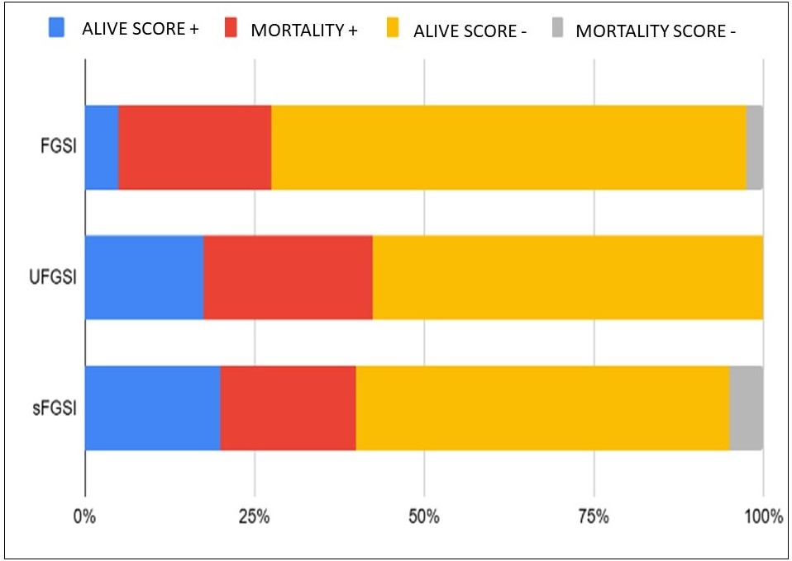

***Figure 2.*** *Mortality is indicated as positive (+) or negative (-) according to each score and the corresponding cutoff point. For the sFGSI, a score of - is interpreted as a value of ≤2, and a score of + is interpreted as a value of >2. For the UFGSI, a score of - is interpreted as a value of ≤9, and a score of + is interpreted as a value of >9. For the FGSI, a score of - is interpreted as a value ≤9, and a score of + is interpreted as a value >9.*

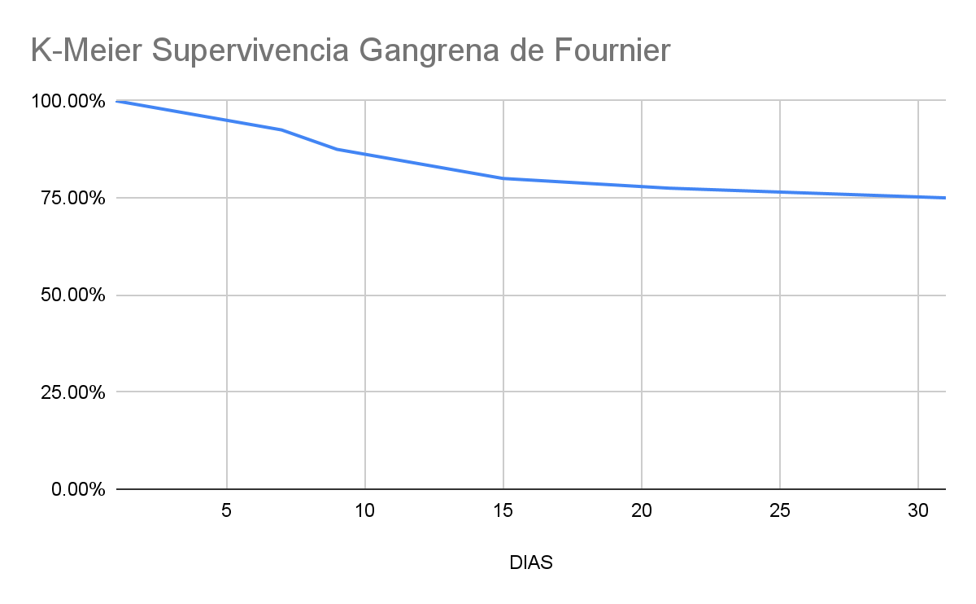

***Figure 3.*** *Kaplan-Meier survival curve.*

**REFERENCES**

1. Eğin S, Kamalı S, Hot S, et al. The importance of the scoring system in Fournier's gangrene. Fournier gangreninde skorlama sisteminin önemi. *Ulus Travma Acil Cerrahi Derg*. 2022;29(1):109-115.
2. Chernyadyev SA, Ufimtseva MA, Vishnevskaya IF, et al. Fournier's Gangrene: Literature Review and Clinical Cases. *Urol Int*. 2018;101(1):91-97.
3. Laor E, Palmer LS, Tolia BM, Reid RE, Winter HI. Outcome prediction in patients with Fournier's gangrene. *J Urol*. 1995;154(1):89-92.
4. Wong CH, Khin LW, Heng KS, Tan KC, Low CO. The LRINEC (Laboratory Risk Indicator for Necrotizing Fasciitis) score: a tool for distinguishing necrotizing fasciitis from other soft tissue infections. *Crit Care Med*. 2004;32(7):1535-1541.
5. Yilmazlar T, Ozturk E, Ozguc H, Ercan I, Vuruskan H, Oktay B. Fournier's gangrene: an analysis of 80 patients and a novel scoring system. *Tech Coloproctol*. 2010;14(3):217-223.
6. Lin TY, Ou CH, Tzai TS, et al. Validation and simplification of Fournier's gangrene severity index. *Int J Urol*. 2014;21(7):696-701.
7. Tufano A, Dipinto P, Passaro F, et al. The Value of Fournier's Gangrene Scoring Systems on Admission to Predict Mortality: A Systematic Review and Meta-Analysis. *J Pers Med*. 2023;13(9):1283. Published 2023 Aug 22.
8. Khan A, Gidda H, Murphy N, et al. An Unusual Bacterial Etiology of Fournier's Gangrene in an Immunocompetent Patient. *Cureus*. 2022;14(7):e26616. Published 2022 Jul 6.
9. El-Qushayri AE, Khalaf KM, Dahy A, et al. Fournier's gangrene mortality: A 17-year systematic review and meta-analysis. *Int J Infect Dis*. 2020;92:218-225.
10. Sarofim M, Di Re A, Descallar J, Toh JWT. Relationship between diversional stoma and mortality rate in Fournier's gangrene: a systematic review and meta-analysis. *Langenbecks Arch Surg*. 2021;406(8):2581-2590.