Original article
DOI: https://doi.org/10.46768/racp.v0i0.197

Oncologic safety and quality of surgery for colorectal cancer in a university teaching center

Álvaro Castro,¹ Alejandra Liz,² Alejandro Soumastre,³ Álvaro Lavega,³ Natalia Fagúndez,³ Marcelo Viola,⁴

Coloproctology Unit, Surgical Clinic "1", Prof. Dr. Fernando González. Hospital Pasteur, Facultad de Medicina, Universidad de la República, Montevideo, Uruguay.

1Adjunct Professor of Surgery, 2 General Surgery Chief Resident, 3General Surgery Resident, 4Associate Professor of Surgery.

The authors declare no conflicts of interest.

Álvaro Castro
castroalvaro@yahoo.com

Received: February 2022. Accepted: April 2022.
Álvaro Castro: 0000-0002-0009-0048
Alejandra Liz: 0000-0002-1530-4782
Alejandro Soumastre: 0000-0003-1933-6949
Álvaro Lavega: 0000-0002-0993-6847
Natalia Fagúndez: 0000-0002-7262-9137
Marcelo Viola Malet: 0000-0003-2733-5276

ABSTRACT
Introduction: It is essential that each surgical team audit the quality of their surgeries, especially in a teaching center that must guarantee appropriate training of oncologic surgery.
Objective: To evaluate the quality of oncologic surgery for colorectal cancer (CRC) in a university hospital.
Material and methods: Retrospective study based on a prospective database of patients operated on for CRC at the Pasteur hospital between 2017 and 2021. Safety of surgery, oncologic quality of the resection and training level of the main surgeon were analyzed.
Results: Eighty-nine patients were included (no gender differences, median age 69 years). The predominant tumor characteristics were pT3 (50%) and pT4 (36.5%), pN0 (60%) and pN1 (29%). The most performed procedures were right colectomy (43%) and anterior rectal resection (40%). Sixty-nine percent were laparoscopic, with a conversion rate of 5%. Anastomotic dehiscence was 9.9%, more frequent in ileotransverse (13%) and hand-sewn anastomosis (16%). There were 10.1% of moderate/severe surgical complications (grades 3 and 4 of Clavien-Dindo classification). Reoperation rate was 11.2% and mortality 2.2%. Median hospital stay was 7 days. The median number of excised lymph nodes was 16. There was no involvement of the distal margin and the circumferential margin was free in 85% of cases. The rectal fascia was complete/almost complete in 93% of the specimens. Almost 70% of surgical procedures were performed by young surgeons.
Conclusion: In our center, CRC surgery achieved international standards of oncologic safety and quality. Most of the procedures were performed by residents and surgeons in training, mentored by senior staff.
Keywords: Oncologic colorectal surgery; Quality indicators; Reference standards; Mentoring

INTRODUCTION
Oncologic surgery is the mainstay of the supposedly curative treatment of colorectal carcinoma (CRC). In this context, it is especially important to offer safe and quality cancer surgery.
There is wide variability in reported surgical outcomes between different surgical teams and centers. In recent decades, the surgical community has been concerned with standardizing colorectal oncologic surgery, with the aim of auditing, monitoring and progressively improving results. To measure and compare them reliably, different quality indicators have been created. It is essential that each surgical team audit the quality of their surgeries, even more so in a teaching center, which must guarantee the correct learning of oncologic surgery.
The aim of this study is to assess the safety and quality of CRC surgery performed in a university teaching center.

MATERIAL AND METHODS
For this retrospective, descriptive study, a prospective database of patients operated on by the Coloproctology Unit of the Surgical Clinic "1" of Hospital Pasteur was used. Eighty-nine consecutive patients operated on for colorectal tumors between December 2017 and September 2021 (45 months) were included. Those who underwent emergency surgery for non-neoplastic pathology and/or with poor data recording were excluded. The following variables were analyzed: 1) safety of the procedure, 2) oncologic quality of the resection, and 3) level of training of the main surgeon. The selected indicators were: 1) surgical safety indicators: anastomotic dehiscence (AD), postoperative surgical complications, reoperations, mortality, and postoperative stay. Postoperative surgical complications were analyzed according to the Clavien-Dindo1 classification, considering grades I and II to be mild and grades III and IV as moderate/severe, considering postoperative mortality that which occurs within 30 days after surgery. 2) Oncologic quality indicators of resection: number of lymph nodes removed, distal and circumferential resection margins and quality of mesorectal excision in rectal cancer. Circumferential resection margin (CRM) was considered negative when it was >1 mm.² The integrity of the mesorectal fascia after mesorectal excision was classified by Quirke as complete (mesorectal plane), nearly complete (intramesorectal plane), or incomplete (muscularis propria plane),³ 3) training level of the surgical team: the time of academic training was considered according to the year of residency (R1 to R5), teaching assistant (grade II), adjunct professor (grade III) and associate professor (grade IV and head of Unit).
The study was conducted in accordance with international ethical standards for biomedical research: Mercosur regulations on the regulation of clinical studies⁴ and the Declaration of Helsinki⁵ and the research regulations approved by the National Ethics Commission in 2019.⁶ The study was approved by the Ethics Committee of our hospital.

RESULTS
Population and tumor characteristics
Of the 89 patients included, 48 were women (54%). The median age was 69 (24-90) years, 35% were ≥75 years old.
The predominant tumor location was the right colon in 34 (38%) cases, followed by the rectum in 23 (26%) and the sigmoid colon in 18 (20%). One patient had synchronous CRC (right colon and rectum). There was one case of familial adenomatous polyposis syndrome with a sigmoid tumor. One case of recurrent rectal cancer at the level of the anastomosis and 1 adenocarcinoma of the last ileal loop adhered to the ascending colon treated with right colectomy, were included.
Eleven out of 23 rectal adenocarcinomas were infraperitoneal and all received complete neoadjuvant chemoradiotherapy.
The most frequent surgical procedures were right colectomy in 39 (43%) cases and anterior resection of the rectum (AR) in 36 (40%) cases (Figs. 1 and 2). In 9 (10%) cases, an extended en bloc resection with neighboring organs was necessary. There were 2 abdominoperineal resections due to lower rectal cancer. The series also includes 4 ultra-low ARs and a combined laparoscopic abdominal approach with minimally invasive transanal total mesorectal excision (TaTME).
The laparoscopic approach was performed in 61 (69%) cases, with a conversion rate of 5% (3 cases). The remaining 28 (31%) were conventional cases. In most patients (81/89) a primary anastomosis could be performed, 63 (78%) were stapled and 18 (22%) hand-sewn. The latter were all ileocolic anastomoses, while all the colocolic and colorectal anastomoses were stapled.
The final pathological staging (pTNM) showed a predominance of pT3 tumors with 44 (50%) cases and pT4 with 32 (36.5%) cases. Fifty-three (60%) cases were N0 and 26 (29%) N1. There was a loss of 2 pathology reports (Table 1).
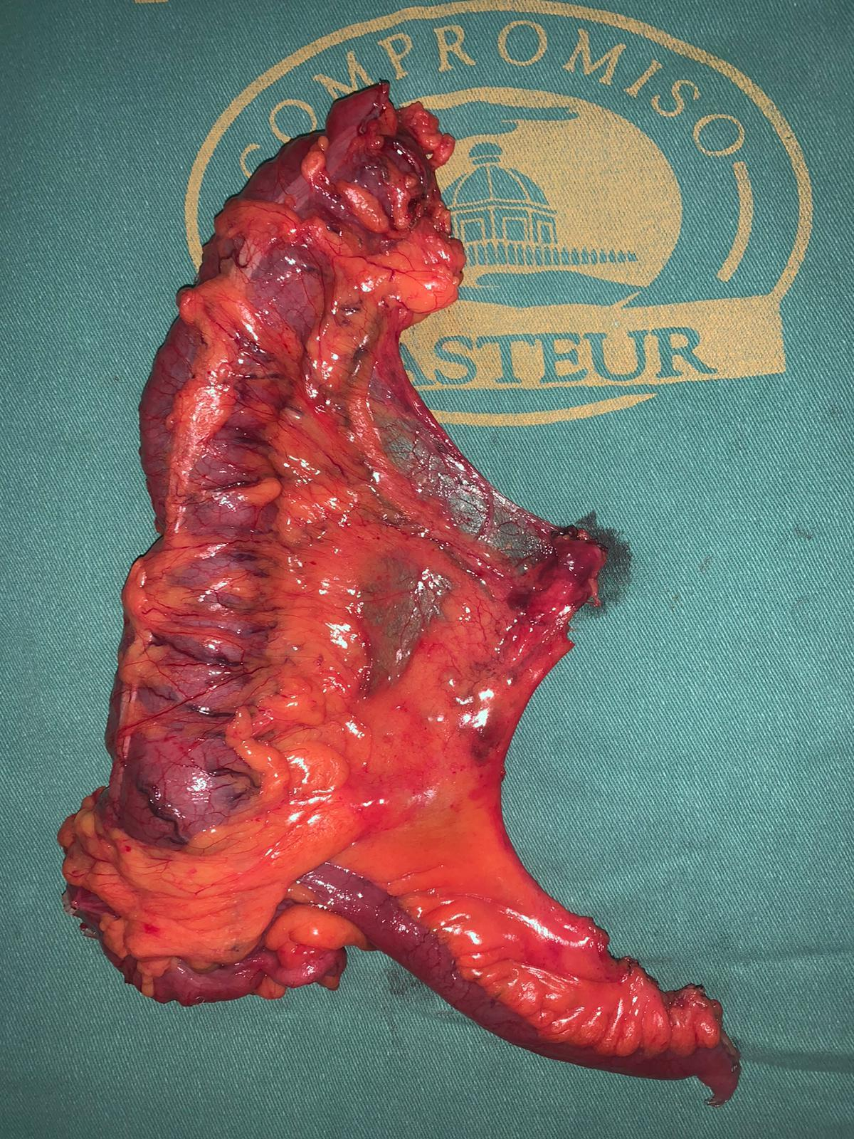
Figure 1. Specimen from a rigth colectomy for rectal cancer. The integrity of the mesocolon and the ligation at the origin of the ileocolic vessels are shown.

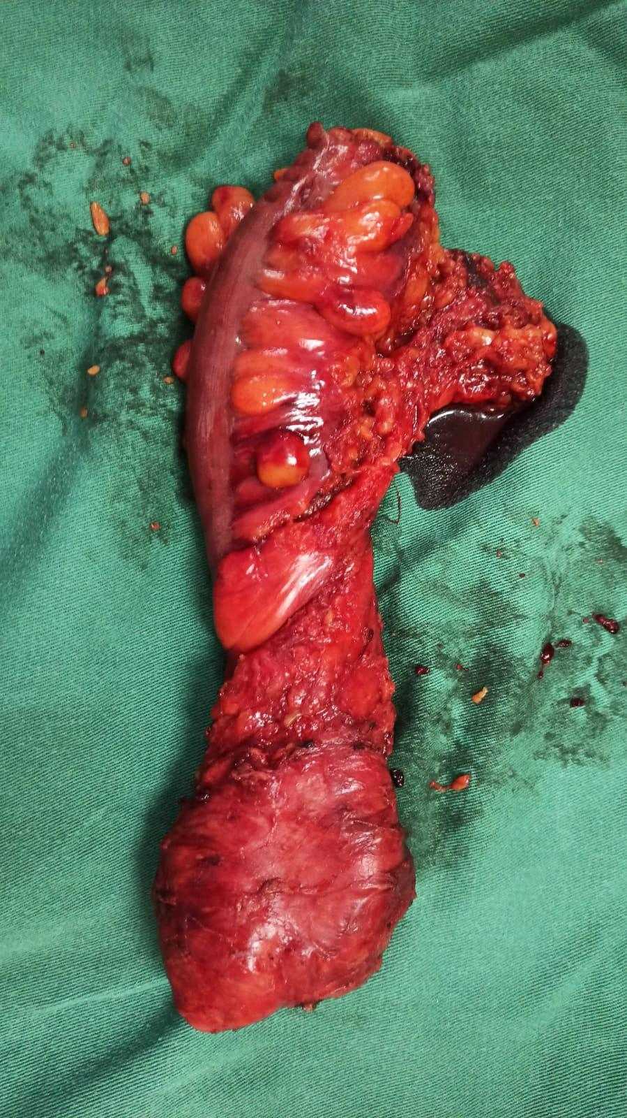

Figure 2. Specimen from an anterior resection of the rectum. Note the integrity of the mesorectum.

Table 1. Tumor location and characteristics of the procedures performed.
 | N= 89
Gender  Feminine  Male | 48 (54)  41 (46)
Age, years  median (range) | 69 (24-90)
Tumor topography  Right colon  Transverse colon  Left colon  Sigmoid colon  Rectum  Infraperitoneal  Neoadjuvant treatment  Synchronous tumor (right colon and rectum) | 34 (38)  5 (6)  8 (9)  18 (20)  23 (26)  11 (48)  11 (100)  1 (1)
Surgical procedure  Right colectomy  Left colectomy  Sigmoidectomy  Anterior resection  Ultra-low anterior resection  Abdominoperineal resection  Total colectomy | N=91*  39 (43)  3 (3)  6 (7)  36 (40)  4 (4)  2 (2)  1 (1)
Anastomosis  Primary  End colostomy | 81 (91)  8 (9)
Type of anastomosis  Hand-sewn  Stapled | N=81  18 (22)  63 (78)
Approach  Open  Laparoscopic  Conversion  Lap TaTME | 28 (31)  60 (68)  3 (5)  1 (1)

* One cancer of the rectum and one of the ileum adhered to the ascending colon treated with a right colectomy, were included.
Lap TaTME: combined laparoscopic abdominal approach with transanal total mesorectal excision.
The numbers in parentheses correspond to percentages, unless otherwise specified.

Safety indicators
- Anastomotic dehiscence: The overall rate was 9.9% (8/81), more frequent in ileotransverse anastomosis with 5/39 (12.8%) cases than in colorectal anastomosis with 3/36 (8.3%) cases. Hand-sewn anastomosis was associated with a higher failure rate than stapled anastomosis (3/18: 16.7% vs. 5/63: 7.9%)
- Postoperative surgical complications: Of 89 operated patients, 36 presented some postoperative complication, 17 medical and 19 surgical. Thus, the rate was 21.3% (19/89) with 10.1% (9/89) of Clavien-Dindo grade III and IV complications, including 8 AD and 1 incisional hernia. The most frequent complication was surgical wound infection, 16.8% (15/89), greater in open surgery with 21.4% (6/28) than in laparoscopic surgery with 14.7% (9/61).
- Reoperations: The rate was 11.2% (10/89 patients). The causes were: 8 AD, 1 evisceration and 1 presacral collection. One patient with AD required 2 reoperations.
- Postoperative mortality: The rate was 2.2%. One patient died on day 3 due to cardiorespiratory arrest and another on day 15 due to AD. Mortality after AD was 12.5% ​​(1/8).
- Postoperative hospital stay: The average hospital stay was 11 days, with a median of 7 (range 3-42) days. In 80.5% of patients (66/82 registered cases) a partial application of the "enhanced recovery after surgery" (ERAS) protocol was performed (Table 2).
Table 2. Safety indicators in surgery.
 | N = 89
Postoperative morbidity  Without complications  Minor complications: Clavien-Dindo I-II  Major complications: Clavien-Dindo III-IV  Anastomotic dehiscence | 53 (59,5)  27 (30,3)  9 (10,1)  8/81 (9,9)
Reoperations  Due to anastomotic dehiscence | 10 (11,2)  9 (73)
Postoperative hospital stay, days  median (range) | 7 (3-42)
Mortality | 2 (2,2)

The numbers in parentheses correspond to percentages, unless otherwise specified.

Indicators of the oncologic quality of the resection
1. Number of nodes removed: The overall lymph node harvest had a median of 16 (range 2-137) nodes and a mean of 19. The maximum number of nodes removed was obtained at total colectomy. If this procedure is excluded, the median number of lymph nodes removed remained 16 (range 2-42). Of the total number of resections, 12 or more lymph nodes were collected in 75.3% (55/73) of the correctly recorded cases. Considering the location of the tumor, in the intraperitoneal resections the number of nodes had a median of 17 and a mean of 20. Twelve or more nodes were removed in 80.6% (50/62) of the cases adequately registered, while in postneoadjuvant infraperitoneal resections, the median number of nodes was 11, with a mean of 10.7, and only 45.5% (5/11) patients had ≥12 nodes removed. Of the total number of removed lymph nodes (1,377), 105 were metastatic. This results in a lymph node ratio (node ​​positive/node removed) of 0.076.
2. Distal and circumferential resection margins in rectal cancer: The distal resection margin in millimeters was detailed in all postoperative pathology reports. In general, the mean was 20 (range 1-120) mm, 25 (range 1-120) mm for intraperitoneal rectal tumors, and 19 (range 5-45) mm for infraperitoneal tumors. CRM was reported in 87% (20/23) of the histopathological studies for rectal cancer. It was negative (>1 mm) in 85% (17/20) of the cases. In 2 of the 3 positive cases the distance was <1 mm and in the remaining case the tumor reached the resection margin. When discriminating the CRM according to the height of the rectal tumor, in intraperitoneal tumors the median was 14 (range 1-33) mm, being negative in 90% (9/10) of the cases. Only one was <1 mm. In infraperitoneal tumors, the median was 5 (range 0-20) mm, being negative in 80% (8/10) of cases. In the remaining two cases, the CRM was <1 mm (in one case due to direct contact with the resection margin).
3. Integrity of the rectal fascia (quality of the mesorectal excision): Of the total of 42 procedures with mesorectal excision (36 AR, 4 ultra-low anterior resections and 2 abdominoperineal resections), the indemnity of the rectal fascia was recorded in 15 (35, 7%) of pathology reports. The mesorectum was complete in 11 cases, almost complete in 3, and incomplete in 1. According to the type of mesorectal excision, of 10 partial excisions, 9 had a complete mesorectum and 1 almost complete. In 5 total mesorectal excisions, the mesorectum was complete in 2, almost complete in 2, and incomplete in 1 (Table 3).

Table 3. Postoperative staging and oncologic quality indicators.
pT  pT0  pT1  pT2  pT3  pT4  pN  pN0  pN1  pN2 | N=87  2 (2)  2 (2)  7 (8)  44 (50)  32 (37)  N=87  53 (60)  26 (29)  8 (9)
Number of nodes removed  Median | N=73  16
Quality of mesorectal excision (Quirke)  Incomplete  Almost complete  Complete | N=15  1 (7)  3 (20)  11 (73)
CRM (rectal tumors)  <1 mm | N=20  2
DM (rectal tumors)  <5 mm | N=24  1
CRM: circumferential resection margin. DM: Distal margin.
Training level of the main surgeon in each surgery
Participation as main surgeon was distributed as follows: residents 33.7% (two R2, 7 R3 and 20 R4), 33.5% GII, 23.6% GIII and 9% GIV (head of unit). In all cases in which the main surgeon was a resident or GII, the procedure was supervised by a senior staff member who was part of the surgical team (Table 4).
Table 4. Training level of the main surgeon.
Main surgeon | N = 89 (%)
R1 | 0
R2 | 3 (3)
R3 | 7 (8)
R4 | 20 (23)
R5 | 0
Teaching assistant (GII) | 30 (34)
Adjunct Professor (GIII) | 21 (23)
Associate Professor (GIV) | 8 (9)

DISCUSSION
Currently, the medical and surgical profession focuses on offering quality care, which can be defined as the degree to which health services achieve the expected outcome for a given pathology.⁷ In order to evaluate it, quality indicators are used. These are quantitative measurements that allow the results of a treatment to be objectively assessed, audited and monitored. Reference values ​​for each indicator allow the results of each team to be compared.⁸
In this context, colorectal oncologic surgery has evolved towards the standardization of perioperative care and surgical procedures, with the aim of offering optimal results in terms of safety and technical quality. This has led to proposing different variables as quality indicators in colorectal surgery.⁹⁻¹⁹
In our study we have selected different quality indicators for the evaluation of the safety and oncologic quality of CRC surgery. Our study population presents the usual demographics for this pathology in our country, with comparable involvement of both sexes and maximum incidence in the 7th decade of life.²⁰⁻²²
The distribution by tumor location was as expected, predominantly in the right colon, rectum and sigmoid colon. Thus, the most performed oncological resections were right colectomy and AR. Almost half of the rectal tumors were infraperitoneal (48%), which entail greater difficulty in their resection and worse prognosis.²³ All received neoadjuvant treatment, the usual practice in our unit.
Almost 90% were advanced tumors, pT3-T4, and 40% had positive lymph nodes, reflecting a failure of national screening programs for early detection of CRC.²⁴
Most of the procedures were laparoscopic (70%), with a conversion rate of 5%; within international parameters.² It is worth mentioning that laparoscopic colorectal surgery in our unit has had a strong boost in recent years, through tutored and progressive learning. In this context, registering, auditing and communicating our results become essential.
Regarding safety indicators of colorectal surgery, anastomotic dehiscence is the most feared complication, since it increases morbidity and mortality. We recorded an AD rate of 9.9%, similar to that reported in different publications.^{18,25-28} The collaborative group of the European Society of Coloproctology²⁹ reports an overall incidence of 8.3% for ileocolic anastomoses. The Spanish Association of Coloproctology establishes an overall rate of <5% as a standard, with an accepted threshold of up to 10%.¹⁸ The German Cancer Society accepts a reoperation rate for AD of <6% for colon resections and <15% for rectum resections, and 9-10% for all colorectal resections.¹⁶
In the present study, AD was more frequent in ileocolic and hand-sewn anastomoses. This striking fact could be explained by the change we have had in ileocolic anastomosis. Initially most were extracorporeal, while in the last 18 months most were intracorporeal, noting a decrease in the frequency of this complication.
The AD rate for colorectal anastomosis (8.3%) is within ​​expected by international guidelines.¹⁶ Cong et al.²⁵report a rate of 8.6% in rectal surgery.
In our series, the rate of postoperative surgical complications was 21%, 10% of them moderate-severe (Clavien-Dindo grades 3 and 4) and wound infection the most frequent (17%), figures within the reference standards. The AEC has established a cut-off value of ≤ 25% for surgical site infection.¹⁸ The German guidelines admit up to 10% of grade III complications as a desired value.¹⁶
The acceptable rate of reoperations for colorectal surgery ranges between 6 and 15%.^{16,18} A Norwegian prospective, observational, multicenter study showed a reoperation rate of 8.7%. In our study, it was 11.2%.³¹
Postoperative mortality is a recognized quality indicator. It has been established that after elective colorectal surgery it should not exceed 5-7%.^{16,18,32} Mortality in our series it was 2.2%, a value similar to that reported by the Spanish ANACO study for colon cancer. Van der Sluis et al.²⁸reported a mortality rate of 4.6% for elective surgery.
The mortality rate due to AD is another classic indicator, since it reflects the response capacity in the face of a serious complication, translating the complexity of the surgical unit and the care center. In our series it was 12.5% ​​(1/8 AD), for a rate established by the literature between 11 and 17%.^{34,35}
Postoperative hospital stay (median 7 days) was similar to that reported in different reference publications.^{17,18,32} It is likely that it can be reduced through better implementation of the ERAS protocol. The socioeconomic level of the population we treat in our hospital must be highlighted, since few patients can meet the standards of perioperative care at home.
Regarding the quality indicators of oncological resection, an oncologically satisfactory colectomy must remove a minimum of 12 lymph nodes to allow correct staging and this has been considered a favorable factor in survival.^{36,37} This cut-off value is controversial, since the final number of lymph nodes detected depends on anatomical and biological factors, the treatment previously performed (neoadjuvant treatment), the surgeon and the pathologist who performs the study.³⁸ In our series, the median lymph node harvest was 16 nodes, complying with the mentioned value. Twelve or more lymph nodes were removed in 75% of cases, coinciding with other national series.^{21,28} However, the German school recommends that this rate should be achieved in ≥95% for elective surgery.¹⁶ The median lymph node count fell to 11 and the rate of ≥ 12 nodes resection to 45.5% in the subgroup of rectal tumors who received neoadjuvant therapy. The decrease is explained in part by the sterilization and destruction of some mesorectal nodes due to the effect of radiotherapy. This fact is well known and has been reflected in other national publications.²²
In rectal cancer, mesorectal excision is the technique of choice. This procedure is technically challenging, especially in low tumors, large lesions, narrow pelvis, or obese patients. In this context, it is critical to obtain tumor-free resection margins, since their involvement increases the risk of local recurrence and worsens the prognosis.²³ In Germany, it has been established that R0 resections should exceed 90%.¹⁶
The distal resection margin is of special interest in lower rectal cancer, due to the proximity of the sphincter complex. In these cases, a distal margin of 5 to 20 mm is acceptable. In our series, it was 20 mm, 19 mm for infraperitoneal tumors. In no case there was direct involvement by tumor, although in one case the DM was only 1 mm.
The CRM in our series was negative (>1 mm) in 85% of cases, a somewhat lower rate than the standard established by the German school.¹⁶ Discriminating it by tumor location, it was 90% for intraperitoneal tumors and 80% for infraperitoneal tumors. This difference is expected due to the lower thickness of the mesorectum in the last cm of the rectum and the greater technical difficulty for resection of low lesions.
The assessment of integrity of the mesorectal fascia is another indicator of quality, auditing the pathologist whether the surgical dissection was carried out in the correct plane.³⁻³⁹ It has been determined that it should be good or moderate in at least 70% of rectal tumors.¹⁶ We must emphasize that in our series this data was specifically reported by the pathologist only in 15 of the 42 procedures in which mesorectal excisions were performed, constituting a significant loss of data for this variable (64%) . The structure of the fascia was complete in 11 of the 15 reported cases (73%) and satisfactory ‒complete or nearly complete‒ in 14 cases (93%). These values ​​were maintained when exclusively considering infraperitoneal tumors, since mesorectal integrity was satisfactory in 4 of 5 lesions in this location. Our results are somewhat superior to those reported by another national series.²²
We believe that the record of mesorectal integrity can be improved by including the pathologist in the clinical meetings of the multidisciplinary team.
Regarding the training level of the main surgeon, the Coloproctology Unit prioritizes comprehensive training of residents and young teachers, by teaching standardized and tutored surgery in the surgical block by members of the senior staff (grades III-IV). Almost 70% of the procedures were performed by residents and young surgeons, all of them tutored by senior teachers who make up the surgical team. The most difficult cases were performed by senior surgeons, reflecting an adequate distribution of procedures according to their complexity, providing each patient with safe and quality surgery.
The present study has the limitation of a retrospective series with a limited number of cases, but adjusted to the reality of our country. In some analyzed variables there was loss of data. However, it has the merit of reflecting real data from our usual practice, allowing verification and identification of areas for improvement.

CONCLUSIONS
This study highlights the importance of surgical teams auditing the quality of their surgical procedures, even more so in a teaching center where the correct learning of the surgical technique must be guaranteed.
To evaluate our results, different safety and quality indicators for CRC resection were measured.
In this series, advanced T3-T4 CRC, operated on mainly laparoscopically, with a low conversion rate, predominated widely.
All oncological quality and safety indicators were satisfactory, within internationally accepted standards.
These results were obtained in the context of a teaching unit, in which most of the procedures were performed by residents and surgeons in training. This highlights the importance of teamwork, the standardization of the surgical technique and its teaching tutored by surgeons with experience in colorectal surgery.

REFERENCES
1. Decreto 158/019. Proyecto elaborado por la Comisión Nacional de Ética en Investigación, vinculada a la Dirección General de la Salud del MSP, relativo a la investigación en seres humanos. Junio, 2019.
2. Lohr KN. Institute of Medicine (US) Committee to Design a Strategy for Quality Review and Assurance in Medicare. Medicare: A Strategy for Quality Assurance: Volume 1. Washington (DC): National Academy Press (US); 1990.
3. Mainz J. Defining and classifying clinical indicators for quality improvement. Int J Qual Health Care 2003; 15:523-30.
4. Nelson H, Petrelli N, Carlin A, Couture J, Fleshman J, Guillem J et al. Guidelines 2000 for colon and rectal cancer surgery. J Natl Cancer Inst 2001; 93:583-96.
5. Schneider EC, Malin JL, Kahn KL, Emanuel EJ, Epstein AM. Developing a system to assess the quality of cancer care: ASCO’s National Initiative on Cancer Care Quality. J Clin Oncol2004; 22:2985-91.
6. Desch CE, McNiff KK, Schneider EC, Schrag D, McClure J, Lepisto E et al. American Society of Clinical Oncology/ National Comprehensive Cancer Network Quality Measures. J Clin Oncol 2008; 26:3631-37.
7. Ludt S, Urban E, Eckardt J, Wache S, Broge B, Kaufmann- Kolle P et al. Evaluating the quality of colorectal cancer care across the interface of healthcare sectors. PLoSOne 2013; 8:e60947.
8. Otchy D, Hyman NH, Simmang C, Anthony T, Buie WD, Cataldo P et al. Practice parameters for colon cancer. Dis Colon Rectum 2004; 47:1269-84.
9. Gagliardi AR, Simunovic M, Langer B, Stern H, Brown AD. Development of quality indicators for colorectal cancer surgery, using a 3-step modified Delphi approach. Can J Surg 2005; 48:441-52.
10. Vergara-Fernandez O, Swallow CJ, Victor JC, O’Connor BI, Gryphe R, MacRae HM et al. Assessing outcomes following surgery for colorectal cancer using quality of care indicators. Can J Surg 2010; 53:232-40.
11. Wesselmann S, Winter A, Ferencz J, Seufferlein T, Post S. Documented quality of care in certified colorectal cancer centers in Germany: German Cancer Society benchmarking report for 2013. Int J Colorectal Dis 2014; 29:511-18.
12. Sancho-Muriel J, Frasson M, Hervás D, Flor-Lorente B, Ramos Rodriguez JL et al. Resultados quirúrgicos estándar tras resección oncológica de colon. Creación de un nomograma para la autoevaluación. Cir Esp 2017; 95:30-7.
13. De la Portilla F, Builes S, García-Novoa A, Espín E, Kreisler E, Enríquez-Navascues JM et al. Análisis de los indicadores de calidad en la cirugía de cáncer colorrectal de unidades acreditadas por la Asociación Española de Coloproctología. Cir Esp 2018; 96:226-33.
14. Bannura G. Estándares de calidad en cirugía colorrectal. Rev Chil Cir 2014; 66:86-91.
15. Barrios E, Garau M, Alonso R, Musetti C. IV atlas de incidencia del cáncer en el Uruguay 2007- 2011. Montevideo: Registro nacional de cáncer. Comisión Honoraria de lucha contra el cáncer 2014.
16. Salvatierra M, González D, Perrone G, Campos Pierri N. Estudio descriptivo de la calidad de la linfadenectomía en el cáncer colorrectal en el Departamento de Salto- Uruguay. Cir Urug 2017; 1:3-10.
17. Chinelli J, Costa JM, Muto M et al. Calidad oncológica en cirugía del cáncer de recto. Rev Med Urug 2018; 34:89-95.
18. Zeballos J. Tratamiento del cáncer de recto. Relato Oficial. 66º Congreso Uruguayo de Cirugía. 2015.
19. Aghazarian M, Alemán A, Ausqui C, et al. Guía de práctica clínica de tamizaje del cáncer colorrectal 2018. Ministerio de Salud Pública – PRONACCAN. Uruguay. 2018.
20. Bakker IS, Grossmann I, Henneman D, Havenga K, Wiggers T. Risk factors for anastomotic leakage and leak-related mortality after colonic cancer surgery in a nationwide audit. Br J Surg 2014; 101:424-32.
21. Nikolian VC, Kamdar NS, Regenbogen SE, Morris AM, Byrn JC, Suwanabol PA et al. Anastomotic leak after colorectal resection: A population-based study of risk factors and hospital variation. Surgery 2017; 161:1619-27.
22. Park JS, Huh JW, Park YA, Cho YB, Yun SH, Kim HC et al. Risk factors of anastomotic leakage and long-term survival after colorectal surgery. Medicine 2016; 95:e2890.
23. Viola M, Laurini M, Muniz N et al. Calidad en cirugía laparoscópica de colon. Resultados a corto y largo plazo en Uruguay. Trabajo libre. Premio Forum. Presentación oral en el 69º Congreso Uruguayo de Cirugía, 2018.
24. Glasbey J, Nepogodiev D, Battersby N, Bhangu A. El-Hussuna M, Frasson B et al. The impact of stapling technique and surgeon specialism on anastomotic failure after right-sided colorectal resection: and international multicentre, prospective audit. European Society of Coloproctology Collaborating Group. Colorectal Dis 2018; 20:1028-40.
25. Cong ZJ, Hu LH, Bian ZQ, Yu MH, Gao YH et al. Systematic review of anastomotic leakage rate according to an international grading system following anterior resection for rectal cancer. PLoSOne. 2013; 8:e75519.
26. Nymo LS, Norderval S, Eriksen MT, Wasmuth HH, Kørner H, Bjørnbeth BA et al. Short-term outcomes after elective colon cancer surgery: an observational study from the Norwegian registry for gastrointestinal and HPB surgery, NoRGast. Surg Endosc. 2019; 33: 2821-33.
27. Bannura G, Cumsille MA, Barrera A, Contreras J, Melo C, Soto D. Resultados del tratamiento quirúrgico del cáncer de colon. Análisis de 439 pacientes. Rev Chil Cir 2010; 62:491-96.
28. Van der Sluis FJ, Espin E, Vallribera F, De Bock GH, Hoekstra HJ, Van Leeuwen BL et al. Predicting postoperative mortality after colorectal surgery: A novel clinical model. Colorectal Dis 2014; 16:631-39.
29. Parés D. Failure to rescue in colorectal surgery: How to minimize anastomotic leak mortality? Cir Esp 2015; 93:483-94.
30. Almoudaris AM, Burns EM, Mamidanna R, Bottle A, Aylin P, Vincent C et al. Value of failure to rescue as a marker of the standard of care following reoperation for complications after colorectal resection. Br J Surg 2011; 98:1775-83.
31. Martinez-Ramos D, Escrig-Sos J, Miralles-Tena JM, Rivadulla-Serrano I, Salvador-Sanchís JL. Existe un número mínimo de ganglios linfáticos que se debe analizar en la cirugía del cáncer colorrectal? Cir Esp 2008; 83:108-17.
32. Hermanek P, Henson DE, Hutter RVP, Sobin LH. TNM Supplement 1993. Berlin: Springer-Verlag; 1993.
33. Lapiedra DE, Cantileno P, Duffau A, Vilas A, Viola M, González F. Lymph node resection in colon adenocarcinoma. Quality procedure revision in an academic center. EC Gastroenterology and Digestive System 2018; 5:761-75.
34. Parfitt JR, Driman DK. The total mesorectal excision specimen for rectal cancer: a review of its pathological assessment. J Clin Pathol 2007; 60:849-55.

